


World Happiness Report 2021

Boot Camp Data Analyst Training
August – November 2025

Project Report written by
Bahador Soori
Lais Amarkhailds
Agnieszka Rogala

Table of Contents

- Introduction: context and stakes
- Implications for decision-making
- About scope and caution
- Key challenges in interpretation
- Exploration
5.1. Global structure and outcome
5.1.1. Key drivers of well-being
5.1.2. Income and context
5.1.3. Social support as a regional lever
5.1.4. Trust and institutional confidence
5.1.5. Distribution of well-being

5.2.. A two-lever lens: how Trust and support Interact with well-being
5.2.1. Life Ladder map: global snapshot (2021)
5.2.2. A two-lever lens: how trust and support Interact with well-being
5.2.3. Top & Bottom 10: contrasting extremes

5.3. Local exploration: how does a country compare to its regional or income peers?
- Summary
- References
- Glossary

1. Introduction: context and stakes

Happiness is measurable and increasingly relevant to public decision-making. The World Happiness Report places well-being at the center of analysis, not as a philosophical ideal but as a composite, experience-based outcome shaped by income, health, trust, and social connection.

The Life Ladder captures this into a single, comparable score. It reflects how people perceive their current life across 149 countries (2021) and enables cross-regional comparisons of lived well-being. For policymakers, this is more than a soft metric – it offers a lens into how effectively institutions convert available resources into quality of life.

This report focuses on six candidate drivers that may help explain variation in Life Ladder scores:

● Logged GDP per capita

● Social support

● Healthy life expectancy

● Freedom to make life choices

● Generosity

● Perceptions of corruption (higher = worse)

Each country is assigned to a regional group. These regions are used throughout to structure comparisons and surface both global patterns and local contrasts.

2. Implications for decision-making

Understanding the factors that consistently go along with a higher scores of the Life Ladder is of critical importance for policy design, development planning, and institutional reform. Though the Life Ladder is a measure of subjective experience, its drivers are often structural and modifiable. Income, support networks, institutional trust, and personal freedoms do not exist in isolation but are part of the social architecture within which lived well-being gets constructed.

Rather than predictive or causal models, this report provides descriptive insight: the identification of stable, interpretable associations across countries and income levels. These associations represent not instructions, but signals indicating where conditions tend to move together, and where they diverge.

The result should not be a checklist, but a decision-oriented narrative. Each visualisation answers a specific policy question: Which are the most influential levers? For which outcomes do patterns diverge from those based on income alone? Which countries over- or underperform compared with their economic peers? The combination of structural benchmarking with contextual storytelling helps to translate abstract metrics into actionable frames. This allows policymakers, analysts, and institutions to compare better, ask sharper questions, and concentrate reforms where they could most likely improve lived outcomes.

3. About scope and caution

This analysis uses data that is cross-sectionally obtained in 2021 as part of the World Happiness Report. This data includes 149 countries and 20 variables. No countries have been left out in the data used for this analysis. Notable countries with extreme values, such as Luxembourg with very high income levels and Afghanistan with low well-being scores have not been left out because they represent real-word data.

No normalization was applied to ensure that it can still be interpreted easily. All visualisations display data using the actual units of the data. GDP is presented on a log-scale because of the large variability in income values per country. This is done to facilitate easy comparison of data, especially among developing countries. Other variables such as social support, freedom, and perceptions of corruption, remain measured between 0 and 1.

The dataset is considered to be complete (0% missing values). It is checked for type consistency and structural coherence. An outlier detection task with the interquartile range method (IQR) is performed to look for leverage points. But no data points were removed, because even extreme values represent real-word socio-economic realities.

All findings presented here are correlative and not causal. Results presented in this report reveal statistical relationships and merely patterns among several nations that seem to regularly co-occur. For instance, there is a high likelihood of finding high scores on the Life Ladder to correspond to high social support in those nations. This may reflect a high association, although it does not imply that high support results in high happiness. It may be the other way around or another variable may influence them.

One variable, generosity, is retained in the correlation matrix for completeness. However, it is not considered as a key driver for two reasons. First, its overall correlation with scores of Life Ladder is fairly low. Secondly, its association with life satisfaction varies in different regions. For example, there can be a high level of generosity in certain regions with low levels of happiness. Vice versa is also true. The association between generosity and life satisfaction is probably due to the nature of generosity measured in the survey. This is because generosity is measured through the percentage of respondents who replied “yes” to the question “Have you donated money to a charity in the past month?”This captures only one type of prosocial behavior and may vary more with cultural norms, tax incentives, or local practices than with underlying altruism or life satisfaction.

4. Key challenges in interpretation

While the Life Ladder provides a consistent and comparable metric of well-being, it is still a survey-based measure derived from people's self evaluations of their current life situation, according to a 0 to 10 scale. To ensure that there are proper interpretations of this indicator, especially when conducted across nations with varied cultures and experiences during the COVID-19 era, there could be potential biases such as modest culture or positivity framing. This means that people could respond to questions regardless of their perception of their current situation.

The purpose of this analysis is to facilitate understanding rather than to rank. Significant and pertinent correlates have been identified and presented in a manner conducive to exploration. These visualisations have been developed to facilitate improved question-askings and sharper comparisons. This is crucial given the context of development.

5. Exploration

How does well-being vary across the world and what factors contribute to such variations? To answer these questions, results will be organized in three sections. Each sections will focus on a unique aspect of the global well-being landscape:

● 5.1. Global structure and outcome: A broad overview of how well-being aligns with structural drivers across regions. This section indicates how countries lie grouped on the Life Ladder and how key variables such as income or social support, differ per global region.

● 5.2. A two-lever Lens: how trust and support interact with well-being: This chapter introduces performance metrics that go beyond income alone. It explores how combinations of institutional trust and social support align with higher or lower levels of well-being. Key visuals highlight top and bottom performers to support policy-relevant insights.

● 5.3. Local exploration: Indeed, at the local focus level, individual countries are analyzed in the context of their regional or income group peers. These profiles support localized insights and comparisons grounded in structural context.

Each section builds on the results of the previous one, ranging from global patterns to detailed hints, and culminating in country-level exploration. The intention is to make the complexity of happiness visible, organized, and action-guiding, but leaving room for further inquiry when there is not a clear-cut answer to questions.

5.1. Global structure and outcome
Which of the structure indicators is associated with well-being to a greater extent? To answer this question, the data is presented through scatterplots because they can easily be used to display the relationship between two variables. Each dot represents a country, placed according to its value on a structural indicator (x-axis) and its Life Ladder score (y-axis). This makes it easy to spot patterns: upward trends, countries with extreme values and clusters that suggest stronger or weaker associations. The purpose of the data presentation is not to model or predict, but to observe where well-being tends to rise or fall in tandem with social, economic, or institutional factors.
5.1.1. Key drivers of well-being
Visualization 1 illustrates four such correlations between Life Ladder scores ans social support, healthy life expectancy, freedom to make life choices, and perceptions of corruption. A color coding is used according to regions. Three plots have marked upward trends:
● Social support displays a tight curve: countries scoring above 0.9 on support tend to have Life Ladder scores above 6 with little variation.
● Healthy life expectancy is increasing drastically, especially above 65 years. It is apparent that life expectancy is associated with increased well-being. This is universal across all regions.
● Freedom to make life choices evidences a moderate positive relationship because although there is a relationship between autonomy and well-beeing, it is not as evident or direct and is probably influenced by other factors and additional context.
By contrast, the association with well-being is negative for perceptions of corruption. The more people in a country perceive corruption to be widespread, the lower the Life Ladder scores. The effect is weaker than those of the other drivers. Together, these four images collectively convey one message: Individuals report their well-being to be comparatively high if support systems, where support systems, life expectancy, and autonomy satisfy certain criteria, and comparatively low if their trust in institutions is affected.
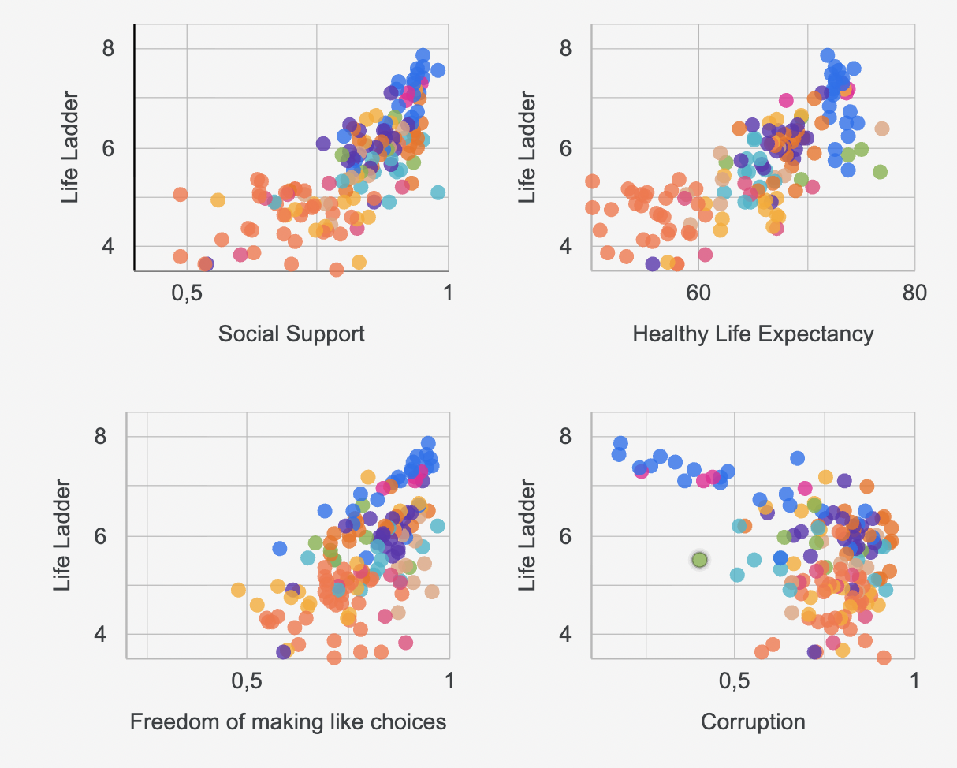
Visualisation 1: Life Ladder vs. Key drivers scatterplots for social support, healthy life expectancy, freedom of making life choices, and perception of corruption. Support and health show strong upward trends; corruption aligns negatively with well-being.

5.1.2. Income and context
Visualisation 2 examines just one relationship: it is between Logged GDP per capita and Life Ladder scores. This is no surprise: there is a direct relationship between income level and well-being - richer countries report higher well-being. But look at the shape of the data and there is a more interesting story. This is not a completely straight line. Some countries - particularly in Latin America - seem to be well above the line. Their well-beeing is high despite relatively low income. Others - particularly rich countries in the far east and eastern parts of Europe - seem to be below the line. Their well-being is lower than their income.
This variant highlights another very important finding: that a nation's Gross Domestic Product (GPD) is able to bring about well-beeing, but it does not guarantee it. Social context, politics, and public services can either accentuate or mitigate the role played by income. A nation's potential could be economic, but its performance is usually social.
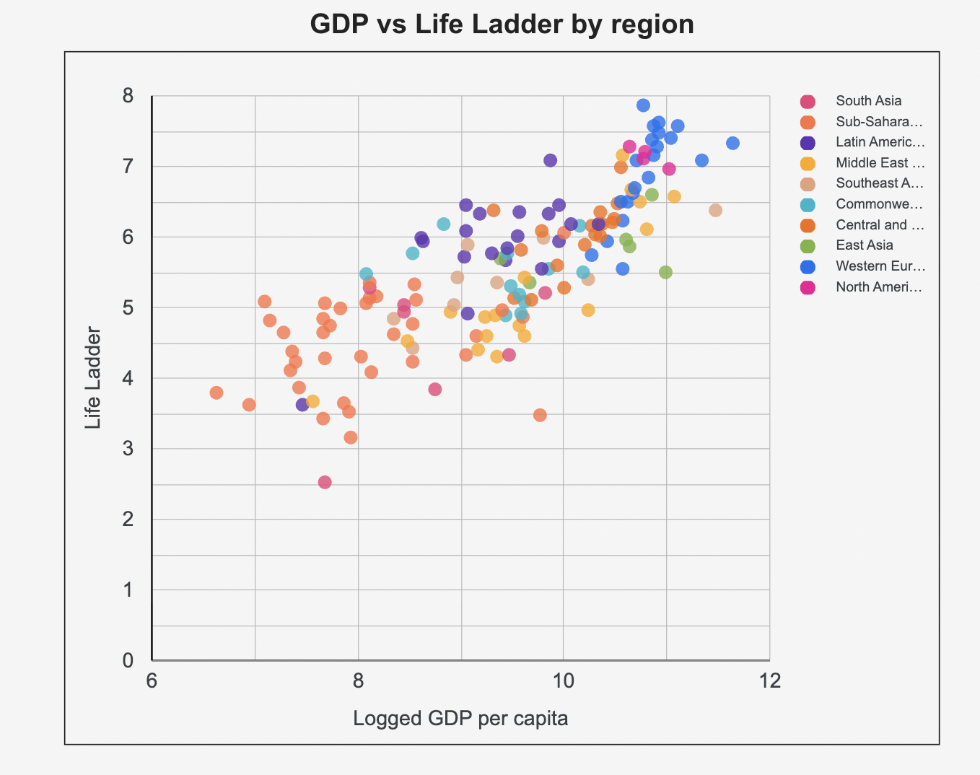
Visualisation 2: Life Ladder vs. logged GDP per capita. Higher income aligns with higher well-being, but regional spreads show that context, not just capacity, shapes lived outcomes.

5.1.3. Social support as a regional lever
Off all the structural factors, social support stands out as the strongest co-mover with Life Ladder, second only to income. But how does this relationship vary across world regions?
To highlight this, Visualisation 3 indicates average social support score for each region. A bar drawn to represent the mean (n = 10 groups) for each grouping of countries. It is evident that there ist:
A score above 0.9 is recorded in Northern and Western Europe, as well as in North America and Australasia. These regions detonate the highest levels of support. Sub Saharan Africa and regions in South Asia have lower support levels with scores below 0.7. This is consistent with the relatively low well-being scores. This is a critical aspect to consider because social support is not just important culturally; it is also important structurally. It is one such factor that converts economic advantages to resilience and satisfaction in regions in which income alone is not enough.
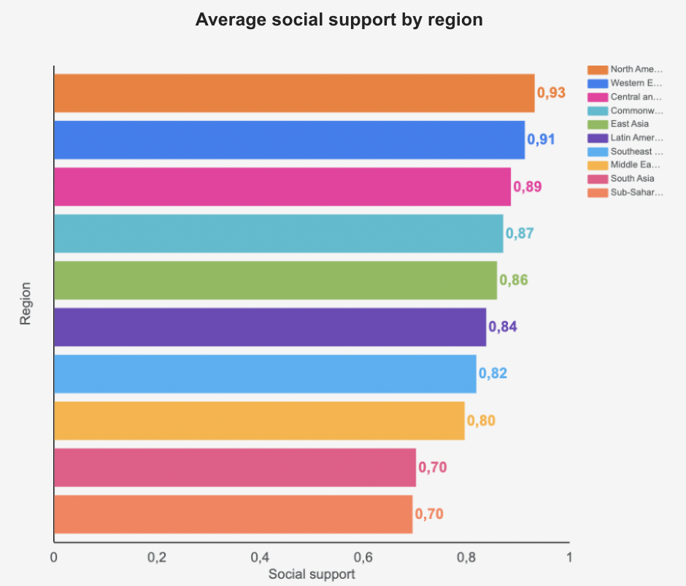
Visualisation 3: Average social support by region. Average social support by region Northern and Western Europe, North America, and Australasia report the highest support levels. Lower support in Sub-Saharan Africa and South Asia aligns with lower well-being outcomes.

5.1.4. Trust and institutional confidence
Although income and social support can increase well-being, a lack of trust in institutions may counteract it. To investigate this question, Visualisation 4 compares the average scores for perceptions of corruption across regions. A larger value indicates more people think that corruption is widespread. The inequality between regions is evident. While Western Europe, North America, and East Asia have the smallest amount of perceived corruption with scores well below 0.4., Sub-Saharan Africa, with scores well above 0.6 in South Asia and certain parts of Latin America, have far more.
This is important because perceived corruption is negatively related with Life Ladder scores. Even with high income and high social support, people rate their well-being lower if they think public institutions are dishonest or not fair. Thus, trust could be a constraining mediating variable because without it, money or community support may not contribute to well-being.
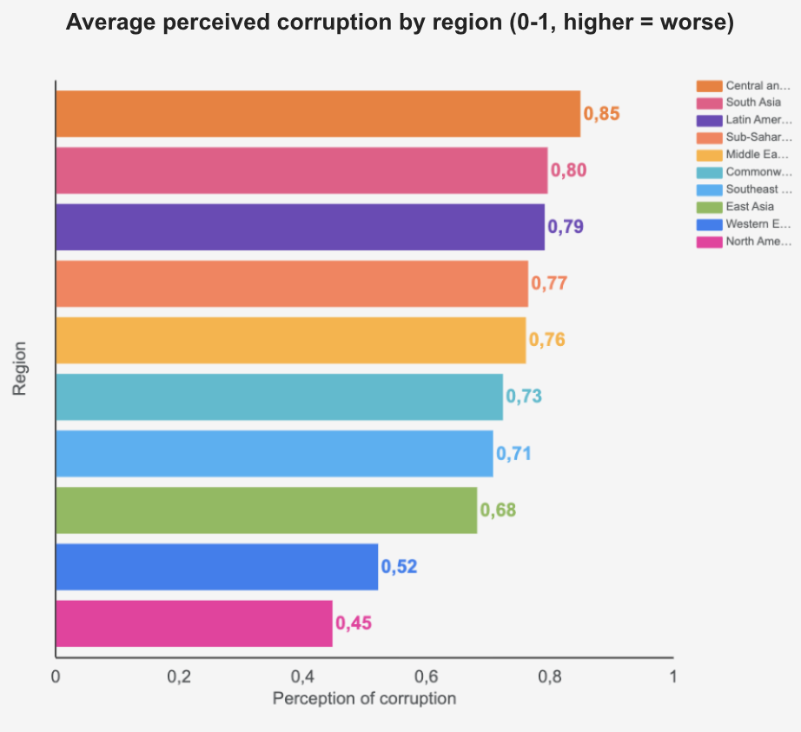

Visualisation 4: Perceived corruption by region. Higher corruption perception scores in Africa, South Asia, and Latin America align with lower well-being despite social or economic capacity.

5.1.5. Distribution of well-being
After analyzing the relationship between the important variables and Life Ladder scores, it is important to look at the distribution of well-being outcomes.
Visualisation 5 is a histogram of the distribution of scores on the Life Ladder for the 149 countries. The distribution is skewed and it can be understood as follows:
● Most countries have a score between 5 and 6. This is indicative of a fairly similar experience of well-being.
● A longer left tail indicates data below 4, which may be due to conflict, instability or poverty.
● At the other extreme, very few countries score above 7.5. This simply reinforces the view that very high levels of well-beeing have not been achieved even in wealthy countries.
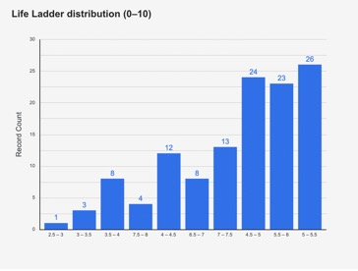
Visualisation 5: Life Ladder score distribution (0–10). Most countries cluster between 5 and 6. A longer left tail reflects lower scores due to instability or poverty; very high scores remain rare.

This word snapshot just reinforces one of the key takeaways from the earlier sections: Income provides opportunities. B outcomes depend on context. A number of countries with similar levels of economic potential score in the same range of 5-6. It is not money that makes them different. It has meaning. Indeed, the histogram is also simple sanity check:
● There are no invalid or outlier data.
● The form is continuous and consistent with past findings.
● The left skew indicates that the Life Ladder does indeed follow how itßs supposed to: with real-world data that has real-world variance.
To simplify the picture Visualisation 6 breaks countries into three meaningful groups:
● ≤4 (low)
● 4-<6 (mid)
● and ≥6 (high)
Nearly 60% of the countries score in the middle band, one-third score in the top tier and a small proportion is classified in the bottom tier.
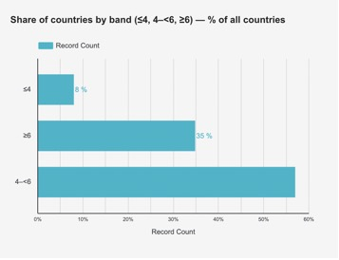
Visualisation 6: Three bands summarize the distribution. Most countries fall into the 4-<6 range (2021 data, 149 countries).

These two figures combine from the anchor of the global center of gravity at 5-6 and convey the message that countries with extreme values do have their place, yet they do not dominate. This pattern is consistent with interpreting the data in one way: Where support, health, freedom, and trust are high, similar kinds of goods will be associated with high evaluations of life.
This lays the groundwork for the next question: To what extent is there alignment between well-being outcomes and income levels? And which countries have higher or lower well-being relative to their income?

5.2. A two-lever lens: how trust and support Interact with well-being
The global pattern (section 5.1.) indicated how well-being is associated with income, health, support, freedom and perceptions of corruption. The next task is more focused and analytical: How effectively do countries turn their economic strengths into their real experience of well-being and what is related to more or less successful outcomes with similar levels of income?
This section introduces a small, easily understandable set of performance indicators to place results in context. The intention is not to produce a league table per se but to place comparison in context – to evaluate a countryßs performance against what is indicated and expected given its position and to direct attention to levers that tend to come with increasing scores on the Life Ladder. To facilitate comparison, scales will follow the units inherent to the data (Life Ladder 0-10; drivers 0-1; perceived corruption: higher is worse). Results will continue to be associational.

Two guiding questions frame the analysis:

● Structural benchmarking: To what extent is a given country’s score high or low relative to what one would have expected given its income level? Rather than forming a model to make a projection here, the figures provide a framework to look at the location of outcomes that stand out and their association with other factors.
● Key factors in context: Which kind of factors, particularly social support and perceptions of corruption, seem to co-occur with improved patterns can be indicated for policy questions without attributing causality.

The section is organized in three visuals that complement each other:

● World map of Life Ladder (Visalization 7) - This is a global image of the distribution of those with higher or lower satisfaction with their lives. This is used to determine the baseline.
● Support vs Corruption quadrant (Visualization 8) - A combined graph of the two primary drivers. It divides the graph according to the global medians (support and corruption) to reveal which levels of trust and support co-occur at a given level of outcome.
● Top & Bottom 10 split bars (Visalization 9) the extremes of the distribution, represented with logged GDP and social support. This comparison makes it easy to see the distribution of drivers to be found in the happiest and the least happy countries.

Taken together, these visuals offer a powerful toolkit that flags relative out- or under-performance and facilitate comparison versus economic peers. It lays the groundwork for section 5.3., in which the same metrics will again be analyzed to focus on individual countries against their regional context.

5.2.1. Life Ladder map: global snapshot (2021)

Before examining the causes underlying the cross-country difference in well-being outcomes, there is a need to take one´s bearings. In which countries is well-being today relatively high or low? The Life Ladder makes it possible to give a direct answer to this question. In 2021, for 149 countries worldwide, people were asked to rate their lives on a 0 to 10 scale to reflect their position in life at the time. This outcome, when presented as a chloroplath map, provides more than just the gradient of color. It provides a patterned geography of well-being. Darker shades denote high percentages found in national averages, and such shades are grouped together in known parts of the world. These parts include Northern and Western Europe, North America, and Australasia. Sub-Saharan Africa, South Asia, and parts of Latin America appear in lighter shades, reflecting lower reported scores.

What is represented in this map is not merely difference, but distribution. This is because, as is well known, there is a median position occupied by the majority of countries with scores ranging between 5-6- This is consistent with the histogram found in section 5.1.5. A very small number of countries score above 7.5. Also, a small number score below 4. These two sets of scores can be identified in the data presented in the map.

At the top of the map, a series of global scorecards places this emphasis in context. The global mean for Life Ladder in 2021 is 5.5, with recorded GDP per capita of 9.4, social support of 0.81, and life expectancy at or above 65. These metrics provide context to the discussion to follow. It is not just to define the places with high or low well-being - not to simply show how well or poorly places translate their potential for life outcomes.

This framework provides the context for what is to follow. The map is not diagnostic – that is, it describes results rather than causes. It does not control for the level variable - and in doing so, it reframes the question that follows. Which countries excel according to their income level? How does support, trust and freedom narrow the gap between promise and performance?

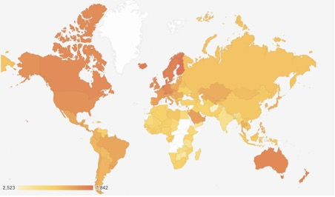

Visualisation 7: Life Ladder map (2021). Darker = higher self-reported well-being; values reflect national averages on a 0-10 scale.

5.2.2. A two-lever lens: how trust and support interact with well-being

As well-being is rarely driven by one variable alone. To gain insight into why certain countries outperform expectations in their life satisfaction with life, it is necessary to consider not individual variables, but rather pairs. The graph provides such insights as it combines two important variables: social support (x-axis) and perceived corruption (y-axis). These variables were chosen not just because they correlate well with well-being outcomes. It is because they represent levers that can be acted upon to a certain extent - both through policy and societal change.
The plot is divided at the global medians for both variables, creating four quadrants. Each dot represents a country. Its position reflects how it scores on both support and corruption, while its color indicates its world region (not its Life Ladder score), allowing regional patterns to emerge more clearly.

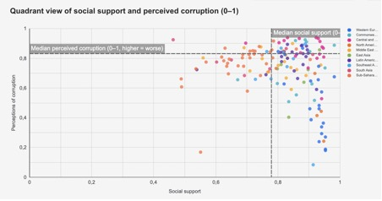
Visualisation 8: Two-Lever Quadrant: social support vs perceived corruption (2021). Each point = one country. Color = world region. Bottom-right quadrant (high support, low corruption) is most often linked with above-average well-being outcomes

A strong concentration appears in the bottom-right quadrant, where social support is high and perceived corruption is low. Countries in this area, such as Canada, Sweden, the Netherlands, or New Zealand, consistently report some of the highest Life Ladder scores. It seems that such societies provide a dual anchor to their citizens: they feel supported by each other, and they believe their institutions to be fair and trustworthy.

The other corner, top left corner, paints a contrasting picture. This is a situation characterized by high perceived corruption and low social support. It is a context known to have among the lowest levels of well-being. This includes Sub-Saharan Africa and Southern Asia. It is a reflection of the effects of a situation devoid of both institutional and personal trust.

The remaining quadrants are more complex. For instance, in Latin America, there is usually strong support even with perceived corruption. On the other hand, there is strong performance on corruption perception with weaker support networks in parts of East Asia. These four quadrants imply that to improve well-being beyond expectations, it is not enough to perform well in one element.

This quadrant insight can be combined with other visualizations to look at such contextual combinations. It not only seeks “where is well-being high?” but also “for which context does well-being exceed projections based on income?” The data provides a definite message asserting that improving both institutional trust and social bonds is a very effective way to increase collective satisfaction.

5.2.3. Top & Bottom 10: contrasting extremes

Our analysis above provides a glimpse of the underlying foundations and combinations of key drivers. Next, we target two poles of the happiness ladder. Which countries rank top and bottom of the Life Ladder and what is the contrast between their income and social capital profiles?
This bar chart provides a side-by-side view of the top and bottom 10 countries in 2021, according to their Life Ladder scores. For each country, we plot not only their subjective well-being scores but also their logged GDP per capita and their average social support levels. This makes it easy to directly compare the amount of economic resources available to them and their apparent effectiveness. A marked divergence can be identified. The top 10 countries, exemplified by Finland, Denmark, and Switzerland, have a fair level of income and high social capital. Social support is always high, with less perceived corruption. These nations have not only the means to live well, but the systems to translate their prosperity into their well-being.

In contrast to this, the bottom 10 clusters tell a differently nuanced story. While it is correct that economic capacity is lower among them, it is not alone in that it is a means of differentiation. Social support is less and feelings of corruption tend to be worse. This is because countries such as Zimbabwe, Lebanon, or Afghanistan can show that even if economic difficulties can be identified to be real in them, still another chasm opens up with regard to well-being.

What is particularly striking about this contrast is that not only is there a gap in their wealth, but their wealth is also differently embedded in their social tissue. Once again, the results confirm a prevailing message: income is important, but it is not the only thing. The factors of trust, security and support usually delimit the boundary between surviving and succeeding.

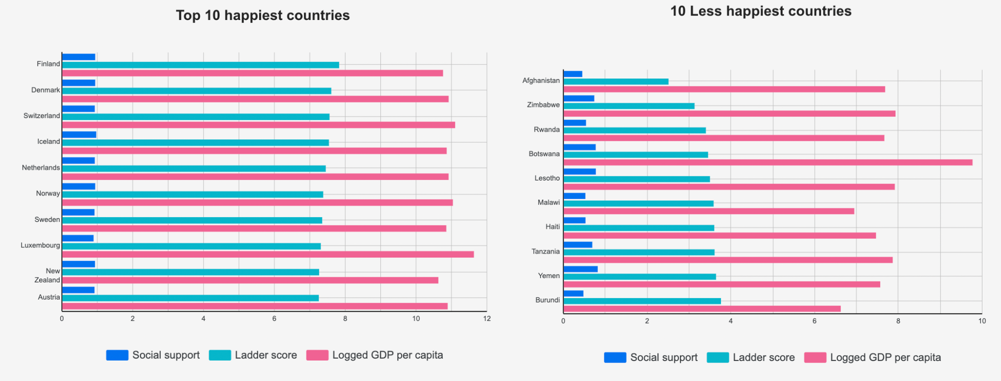

Visualisation 9: Top vs Bottom 10 Countries in Life Satisfaction (2021). Comparison of Life Ladder score, GDP per capita (log), and social support for highest- and lowest-ranking countries.

5.3. Local exploration: how does a country compare to its regional or income peers?

Not every country follows the pattern of its region. Sure enough, we have observed that those with little corruption combined with high social support experience high well-being. But look closer: Not every country in a given region is the same. Certain countries stand out for outperforming or falling short of their regional peers despite similar context. This comparison method allows a nation to be measured against the regional average with regard to several factors of well-being: social support, perception of corruption, freedoms, Gross Domestic Product per capita and healthy life expectancy.

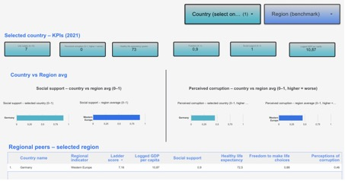

Visualisation 10: Selected country vs. regional benchmark (2021). Social support and perceived corruption compared to regional average.

Consider Germany in 2021. With a Life Ladder score of 7.16, it is among the top countries inWestern Europe. On social support score, it is 0.9, just below the regional average of 0.94. But it stands out on the corruption score with a near-perfect 0. This is against a high average of 0.18 in the same category in the region (where higher scores mean worse corruption). This advantage could be why Germany scores slightly above richer countries. It does not score first in life expectancy or in GDP per capita.
This comparison among nations strengthens strategic focus on:
● Where do we already lead?
● Where are we falling short?
● Are we an extreme value country and is it working for or against us?
This dashboard can help answer such questions because it highlights the deficiencies and strengths not evident in averages.

6. Summary

This report focused on the global distribution of subjective well-being and its structural drivers, using data from the 2021 World Happiness Report. The primary task at hand did not involve modeling or creating rankings. The focus remained on identifying meaningful patterns that could help with improved decision-making.

Three layers of analysis have been used to organize the report:

● Global structure (section 5.1.): This level mapped out the relationships between key drivers, such as income, social support, healthy life expectancy, and perceptions of corruption and self-reported well-being. It showed that higher Life Ladder scores tend to co-occur with strong support networks, longer lives, and lower levels of perceived corruption. Importantly, the analysis also highlighted that GDP alone does not guarantee higher well-being: context, including social and institutional factors, is critical.
● Conversion and comparison of performance (section 5.2.): Here, performance indicators were introduced to evaluate the effectiveness of conversion between structural strength and well-being. By looking at both benchmarking and a mix of drivers (for example support and corruption), the report highlighted interesting differences such as comparison between less wealthy nations with high well-being or rich nations with poor performance. These methods enable us to easily identify ineffective performance and those levers for social change that have been overlooked.
● Local exploration (section 5.3.): Finally, the focus shifted to individual countries to see how their profiles match up against similar ones at regional or income level. Through country-based dashboards, it was identified how countries score high or low on the measures of support, trust, and outcome alignment. For instance, Germany was identified as one such country where high levels of institutional trust seem to have effects on well-being above and beyond what is expected given their income.

Throughout the report, patterns rather than prescriptions have been highlighted. The purpose is to facilitate informed questions rather than definitive answers and to offer a condensed framework of analysis apt for cross-country learning. Although every finding presented is correlative rather than causal, the consistencies in the patterns afford very credible indicators for further exploration in the indicated directions.

Conclusion: Well-being is not a puzzle to be solved. It is a structured and patterned phenomena. It can be partially guided. By understanding the interrelation between structure and subjective experiences of life, it is possible to decide realistic solutions.

7. References

Data (analysis): Kaggle, World Happiness Report 2021 (149 × ~20; 0% missing used here).
Reference (context): Official World Happiness Report 2021 editorial chapters (definitions, conceptual framing).
Helliwell, J. F., Layard, R., Sachs, J., De Neve, J.-E., Aknin, L. B., & Wang, S. (2021). World Happiness Report 2021 – Statistical Appendix 1 (p. 2). Sustainable Development Solutions Network https://files.worldhappiness.report/WHR21_Statistical_Appendix_01.pdf

8. Glossary

Life Ladder: A self-reported measure of well-being from 0 (worst possible life) to 10 (best possible life). Respondents place themselves on this scale based on their current life evaluation.

Logged GDP per capita: The natural logarithm of a country’s GDP per capita, used to reflect diminishing returns of income on well-being. Higher values imply greater economic capacity.

Social Support: The proportion of people who report having someone to count on in times of need. Scaled 0-1, higher values indicate stronger support networks.
Healthy Life Expectancy: The average number of healthy years a person is expected to live, adjusted for disability and disease burden.
Freedom to make life choices: The share of people who feel free to make key life decisions. Scaled 0-1.
Perceptions of Corruption: The share of people who perceive widespread corruption in government and business. Higher values indicate lower institutional trust.

World Happiness Report 2021 – Statistical Appendix 1, p. 2. Available at: https://files.worldhappiness.report/WHR21_Statistical_Appendix_01.pdf

